European Research Network about Parents in Education

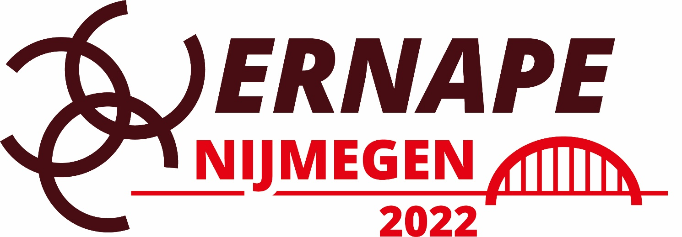

13th Biennial ERNAPE Conference

29 – 30 – 31 August 2022

Parents in education:
Reconciling theoretical perspectives and empirical research approaches

Radboud University
Nijmegen, The Netherlands
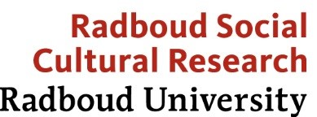

ERNAPE Nijmegen
Important dates

1 December 2021
Opening call for proposals

15 February 2022
Closing call for proposals

1 April 2022
Final decisions

1 May 2022
Preliminary programme publication

15 May 2022
Deadline Early Bird registration

29– 31 August 2022
ERNAPE Conference @ Radboud University Nijmegen, The Netherlands

In the past decades, parents in education have been studied extensively. The engagement of parents in their children’s education has received attention from a broad range of disciplines, such as sociology, educational science, cognitive psychology, philosophy, macro-economy, and political sciences. These disciplines all have their unique and relevant perspective on the theoretical underpinnings of parent-school-community relations and how these relations may be understood, built and strengthened to foster student learning, empower families and support strong schools, communities, and societies.

ERNAPE brings together all those interested in school-family-community connections and has established a research community in which researchers with an interest in school-family-community relationships share their ideas and work, bringing their own perspective into the scientific discourse. ERNAPE has become a multidisciplinary group of researchers in this field studying parents in education by using different theoretical lenses and also with a variety of research methods. Researchers with various disciplinary backgrounds employ qualitative, quantitative, and mixed-methods designs, with survey studies, small scale interview studies, intervention studies, critical narrative analyses, and so forth.

A flourishing research network is one that embraces this diversity and engages in strong efforts to build bridges across disciplinary boundaries and that enables dialogue between researchers with different research backgrounds. Therefore, for this conference we explicitly invite contributions that aim to discuss, combine, reconcile and integrate different theoretical perspectives and research approaches on parents in education.

So, all interested researchers are invited to submit proposals for ERNAPE 2022. We welcome proposals that relate to the main conference theme, and we also welcome proposals for contributions on all topics relevant for ERNAPE. Contributors may want to address any of the following thematic areas but are not restricted to these:

Theoretical issues in family-school-community partnerships:
- Uni-disciplinary, multi-disciplinary and inter-disciplinary perspectives on parental involvement in education.
- How critical must theory be?
- Discussions on the ‘what works’ paradigm.

Methodological issues in research:
- Empirical approaches to understanding parental involvement in education.
- Empirical approaches to evaluating parental involvement in education.
- Empirical approaches to improving parental involvement in education.

Family-school-community partnerships:
- For inclusion and social justice.
- In multicultural and multilingual contexts.
- In the context of educational inequalities: are they the solution or the problem?

Further thematic areas:
- Discussions about the concept of ‘family’ from feminist and queer theory perspectives.
- Interventions on families, schools and communities for promising partnerships in education.
- Connecting home and school: social media for family-school partnerships.
- Family-school-community partnerships in a Covid-19-era.

conference@ernape.org

www.ernape.org/conferences/nijmegen-2022/
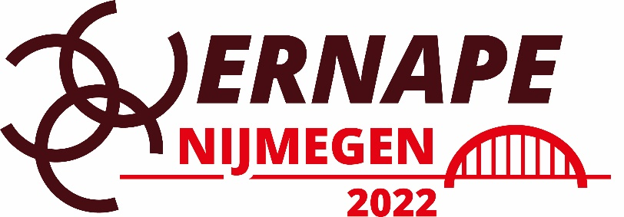
Conference chair
Eddie Denessen

ERNAPE steering commitee
Unn-Doris K. Bæck, Gill Crozier, Ida Karen Danneboe, Eddie Denessen, Limin Gu, Raquel-Amaya Martinez-Gonzalez, Maria Mendel, Helen Phtiaka, Michelle Pieri, Birte Ravn, Loizos Symeou, Pedro Silva, Maria Adelina Villas-Boas

Local scientific commitee
Teije Boeijen, Eddie Denessen, Mienke Droop, Margriet van Hek, Gerbert Kraaykamp, Judith Stoep
Proposal submissions
Paper sessions
Paper sessions are 20 minutes in total for each paper. Each presentation consists of oral presentations that last approximately 10 – 15 minutes followed by 5 – 10 minutes for questions. Paper presentations will be scheduled in 90 minute sessions which will normally include four papers on similar topics (in sessions with three papers, the time for each paper will be 25 minutes). There will be a chairperson for each session who will take care of time and manage discussion. The chair person is nominated by ERNAPE-Nijmegen.

Poster sessions
Posters are graphical presentations which will be displayed during the whole conference and presented in a special Poster Session. Presenters will be asked to be available at the Poster session to answer questions from other conference delegates. Posters should be prepared for the Conference in A1/portrait (upright).

Symposia
Symposia consist of a 90 minute session organised by the submitters. A symposium session includes 3 – 5 papers plus a discussant. The symposium needs to be handed in as one submission with a description of the symposium (500 words) and a list of all abstracts for all papers linked to it (200 word abstract per paper). The proposer appoints a chairperson and a discussant and these must be named in the proposal. The discussant’s role is to read all abstracts ahead of the symposium and offer a reflection on the symposium as a whole.

Full papers
ERNAPE-Nijmegen invites participants to submit full papers to be reviewed for publication in The International Journal about Parents in Education (IJPE). Full papers will also be presented in the paper sessions and symposia.

ERNAPE and Radboud University Nijmegen invite all interested researchers to submit proposals for ERNAPE-Nijmegen, the European Research Network About Parents in Education Conference in 2022.

We welcome proposals that relate to the main conference theme, and we also welcome proposals for contributions on all topics relevant for ERNAPE.

Online submission of proposals will be open between December 1st 2021 and February 1st 2022. Authors will receive the Scientific Committee’s decisions on the acceptance of their proposal by April 1st 2022.

ERNAPE-Nijmegen welcomes the following formats of presentations:

- Paper sessions
- Poster sessions
- Symposia

Participants are invited to hand in abstracts for papers, posters and symposia.

All submission of proposals for papers, posters and symposia via:

www.ernape.org/submission/

In the abstract submission the author will be asked to specify to which topic at ERNAPE-Nijmegen the author wants to present a paper. The scientific committee does, however, reserve the right to assign papers to the another session as it best sees fit.
How to submit an abstract
Participants are invited to hand in abstracts for papers and posters, and proposals for symposia. Online submission of proposals will be open between December 1st 2021 and February 1st 2022. Authors will receive the Scientific Committee’s decisions on the acceptance of their proposal by April 1st 2022.

All paper, poster and symposium proposals must be submitted electronically via:
www.ernape.org/submission/

You need to indicate all contributing authors along with their affiliations and email addresses. Fill in this information carefully; misspellings and missing email addresses may result in that co-authors are not correctly linked to all their contributions.

The abstracts should be maximum 350 words and include the following:

- Title of abstract
- Authors(s) of abstract including affiliations
- The topic where you feel that your abstract will best fit
- Keywords
- General description on research questions, objectives and theoretical framework
- Methods/methodology (if applicable)
- (Expected) outcomes/results
- References (references are not included in the word count)
Please note the following points that are important for a correct submission :
- It is not possible to include tables or graphs in the submission form
- The conference language is English and all abstracts must be in English
- Submissions are limited to new, original work
- All abstracts will be published in the Abstract Book of the 13th Conference
- Full papers will be published in The International Journal about Parents in Education (IJPE)

How to submit a symposium proposal
A symposium session builds on a theme and is proposed and planned by a symposium organiser. The papers focus on a common theme. A symposium has a chair (often the organiser) and a discussant, who has read the papers in advance. The symposium organiser will decide how the symposium is to be organised and the time allotment for each presentation. Only the person who submits the proposal will receive correspondence relating to the submission. The submitter is responsible for communicating with all contributors and with ERNAPE-Nijmegen about the proposal.
In addition to the general abstract requirements, proposals for symposia must also include:
- A plan for the symposium including:
  - (1) The title of the symposium, and
  - (2) An abstract describing the entire symposium (500 words).
- Names of chairperson and discussant for the Symposium.
- Short abstracts (200 words) of all papers within the symposium.
- The names of the contributors along with their affiliations and email addresses, titles of their presentations and their abstracts. Names of those presenting must be specified.
Further guidelines for submitting a full paper
ERNAPE-Nijmegen invites participants to submit full papers to be reviewed for publication in The International Journal about Parents in Education (IJPE).
When you submit an abstract for a paper or symposium you may be asked whether you would like to submit a full paper for publication in the IJPE. In that case, you will receive further guidelines from the IJPE- editors.

If you have any questions, please contact: conference@ernape.org

www.ernape.org/conferences/nijmegen-2022/

